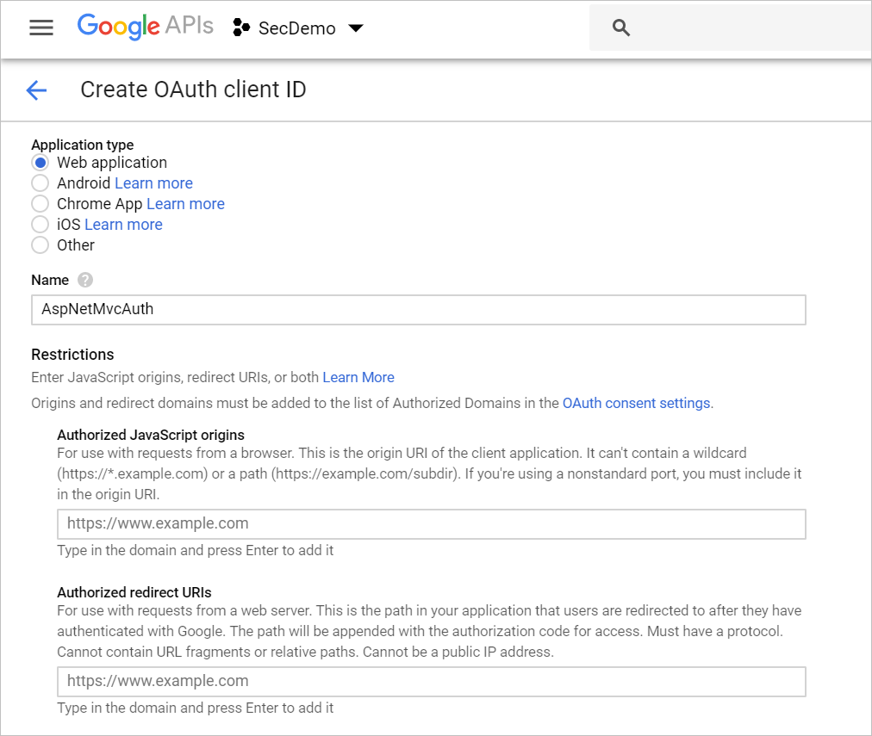

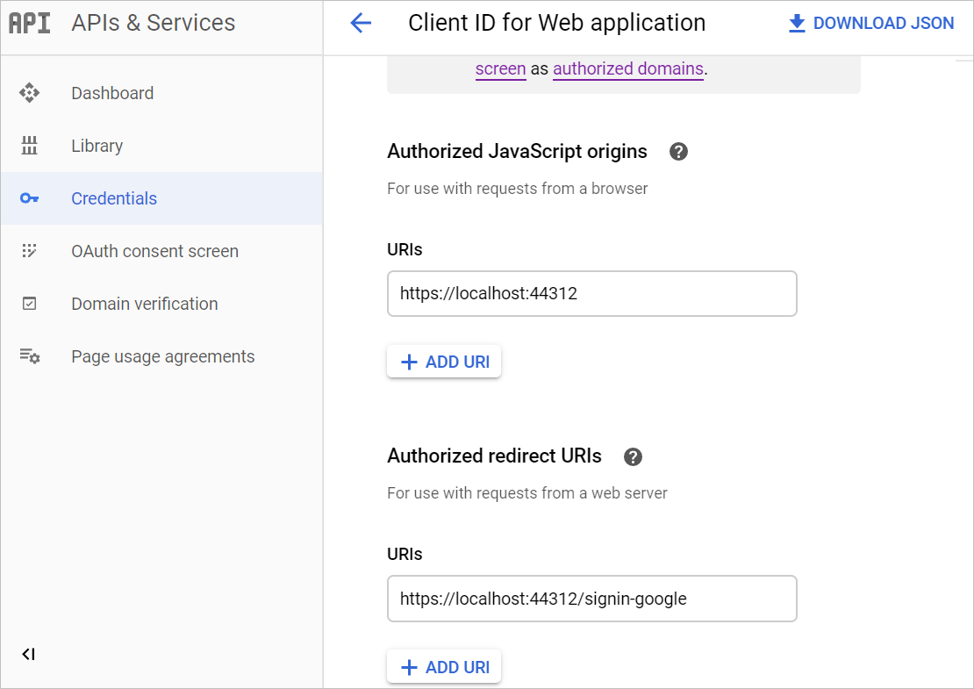

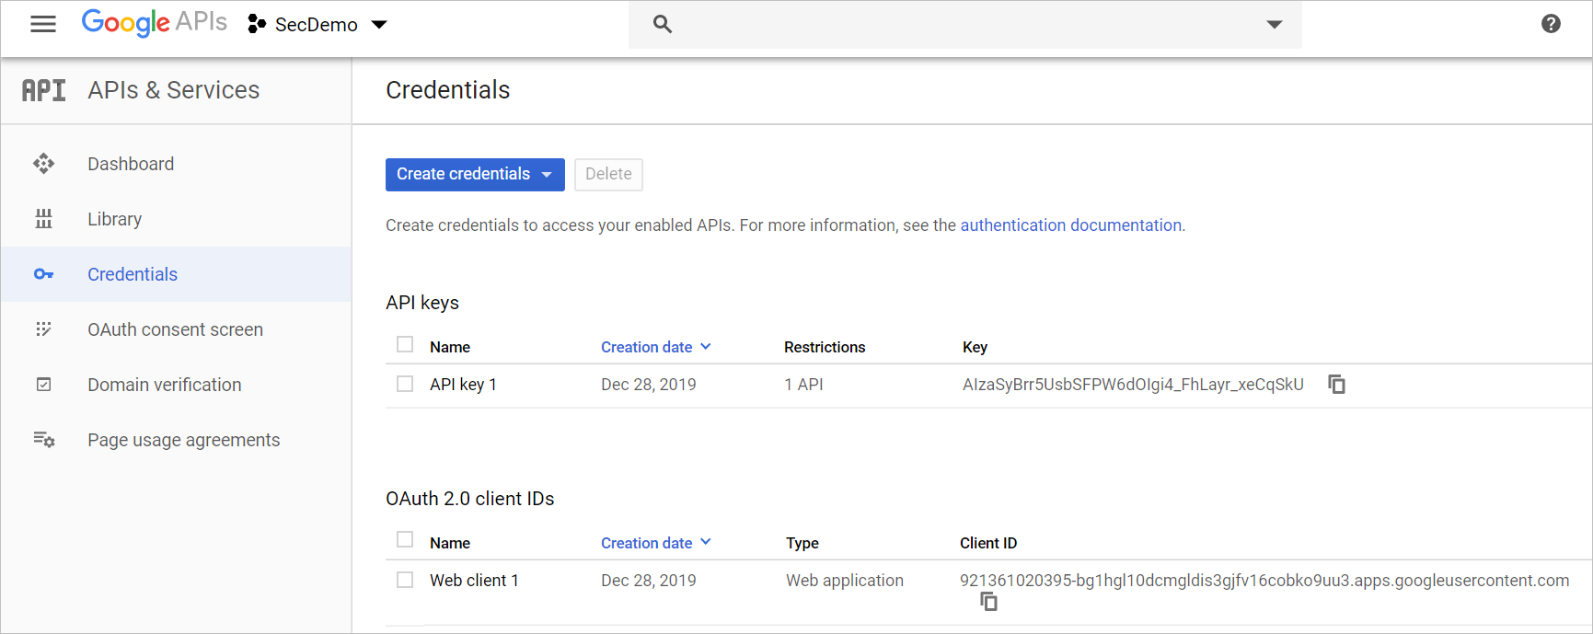

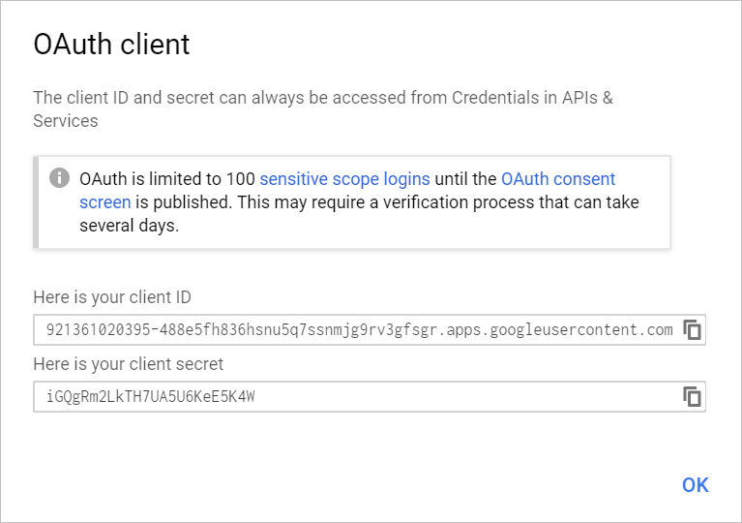

Client ID:

921361020395-488e5fh836hsnu5q7ssnmjg9rv3gfsgr.apps.googleusercontent.com

Secret:

_BX6Rne7sAEXYoU3YqtTLnEA

<https://joeraio.com/using-google-authentication-with-asp-net-core-asp-net-5/>